Careers Education, Information, Advice and Guidance Policy
Careers Education, Information, Advice and Guidance (CEIAG) Policy
SLG MI Pack – 4th December 2017

SLG MI Pack – 4th December 2017

- Scope and Purpose

  - The purpose of the policy is to set out the Information, Advice and Guidance services the College commit to provide to prospective and current learners and the parents of learners under the age of 18.

  - The policy is designed to ensure consistent, effective and fair treatment for all. This policy has been impact assessed to ensure that it does not adversely affect users on the grounds of sex, transgender, marital or civil partnership status, racial group, nationality, sexual orientation, religion or belief, disability of age.

  - The policy should be read in conjunction with other College policies and procedures including Admissions, Equality and Diversity, Data Protection, Freedom of Information, Teaching and Learning, Safeguarding and Tutoring policies, etc.

- General Principles

  - Information, Advice and Guidance (IAG) is provided on the College website, the student intranet, in College prospectuses and is available free of charge to any individual on request.

  - Learning and training information is provided by the Advice and Guidance team and, depending on the nature of the query, by other support or curriculum staff. Advice covers areas such as employability, work experience, the importance of Maths and English qualifications and progression to university. The service embeds the software package, Career Coach which provides learners with information on career pathways and live local labour market data. Where the College does not have the information being requested, it will seek the information on behalf of the individual or provide the individual with the name and contact details of the relevant organisations.

  - Advice is provided on an impartial and confidential basis to help clients to make informed decisions about their future career and the most appropriate pathway for their continued development. Advice and guidance is provided by the Advice and Guidance team, other support and curriculum staff.

- Responsibilities of Staff

3.1 Staff are responsible for ensuring that any enquiry they receive for IAG is passed to the appropriate member of staff and that the individual requesting information receives a response within three days of their request.

3.2 Advice and Guidance, other support and curriculum staff work with prospective and current students to provide information, advice and guidance at different stages in the learner journey as shown in appendix 1.

- Statement of Service

  - The College provides:

- Pre-enrolment information, advice and guidance both on-site and to local schools via outreach.

- Initial information, advice and guidance on learning and training opportunities, qualifications and support with learning, funding, travel and childcare issues.

- On-going careers education, information, advice and guidance on learning and work issues through personal tutors, assessment, support services, careers events, counselling and referral to specialist organisations.

- Special sessions provided to work with and support various targeted groups.

- Information, advice and guidance on progression routes including Further and Higher Education, Apprenticeships and employability.

  - The College IAG services are impartial, free and can be accessed via face to face sessions,
telephone or email. The College endeavours to provide the IAG in a format most appropriate to the
client.

- IAG Delivery

  - The College:

- Offers impartial information and advice on choosing the most appropriate learning programmes to suit the needs of individual students including an awareness of English and Maths within the programme of study.

- Provides information and advice on local and national learning and training opportunities.

- Aims to meet the needs of the local economy by providing information and advice related to business training needs.

- Supports current students during their learning by providing careers advice and guidance.

- Encourages its staff to provide learning opportunities in real working environments.

- Offers students support in preparing for and finding employment, apprenticeship opportunities and work experience through the Employer Hub.

- Helps students to develop career management skills and raise awareness of future career options

- Maintains up to date, relevant careers resources on the options available, including access to IT based careers packages.

- Offers on-site careers services for all ages.

- Supports students in progression to their chosen destination

- Works with the National Careers Service, to facilitate indepentdent advice for our students.

- Offers an on-line application system for convenience

- Promotes the welfare and educational achievement of looked after children and care leavers.

- Ensures all possible steps are taken to oversee the identification of looked after children who enrol at the college so that appropriate financial, academic, social and emotional support can be offered.

- Recognises that looked after children may be particularly vulnerable and they will be offered access to mentors to build a positive relationship, increase confidence and motivate achievement in education.

- Works with our local schools to provide an outreach programme for year 10 and 11 pupils providing impartial IAG sessions, attending careers event and parents evening, facilitating application workshops, hosting group visits to the college and providing information in school assemblies.

- IAG – Health

The College offers information and advice on personal wellbeing through the student counselling service, on-site nurse, student mentors and personal tutors, the safeguarding team, welfare officer and student finance.

- IAG – Finance

The College offers information and advice on:

- Fees and loan schemes

- Financial assistance for low income families including lunch and breakfast vouchers and bursaries.

- Travel schemes

- Careers Education

  - The College provides a comprehensive careers education programme within its full-time further
education study programmes. The programme seeks to ensure that as well as studying their core vocational qualification that our students are able to enhance this with the opportunity to engage in additional learning activities designed to make them ready for work once they have finished their studies at the College. A list of our employability activities may be found in Apprendix 2.

- Referral

  - Clients are referred to appropriate organisations or internal departments based on the client’s current situation and level of need.

  - Clients are referred after joint discussion and agreement.

  - Students indicate their progression intentions through Proportal, their electronic ILP, and an application form is completed. The personal tutor charts intentions, Advice and Guidance team support the process through IAG and interview arrangements where required. Designated tutoring days are allocated in March where the main focus is progression.

- Confidentiality

  - All information gathered during discussion with a client is regarded as confidential. Any
limitations with regard to confidentiality only apply to safeguard the individual from harming themselves or others following disclosure. The client is made aware of this at the start of a session.

- Service Standards

  - The College is committed to national CEIAG principles and individuals can expect the College to
provide a service that is:

- Professional and knowledgeable
- Confidential
- Impartial
- Open and transparent
- Accessible and visible
- Committed to equality of opportunity
- Responsive

  - The College will:

- Respond to all enquiries promptly, within 3 working days
- Refer to other learning providers and specialist organisations if we are not able to meet the client’s needs.
- Provide prospectuses and course information leaflets
- Offer a range of open events at the College and at other locations, including schools and community events
- Maintain the College website
- Offer telephone and email accessibility
- Offer drop-in and booked appointments
- Aim to meet all school requests for outreach work.

- Feedback

    - The College welcomes feedback on the service we provide. Clients can give feedback anonymously if wished. The College uses the information received to improve the service.

    - If our IAG services do not meet client expectations, we aim to try to resolve any issues informally at first. If the matter cannot be resolved this way, it is referred to our Quality office.

    - Details of our Complaints procedure are available on the website or on request from the College.

- Responsibilities

12.1 The Vice Principal – Planning and Information Services is a member of the Senior Management Team with responsibility for CEIAG.

12.2 The policy is reviewed annually and complaints and compliments reported on.

- Equality Impact Assessment

The CEIAG Policy is fully inclusive and does not negatively impact on any specific groups. The services provided are available and accessible to all.

Appendix 1 – The Learrner Journey Signposting Support Interventions
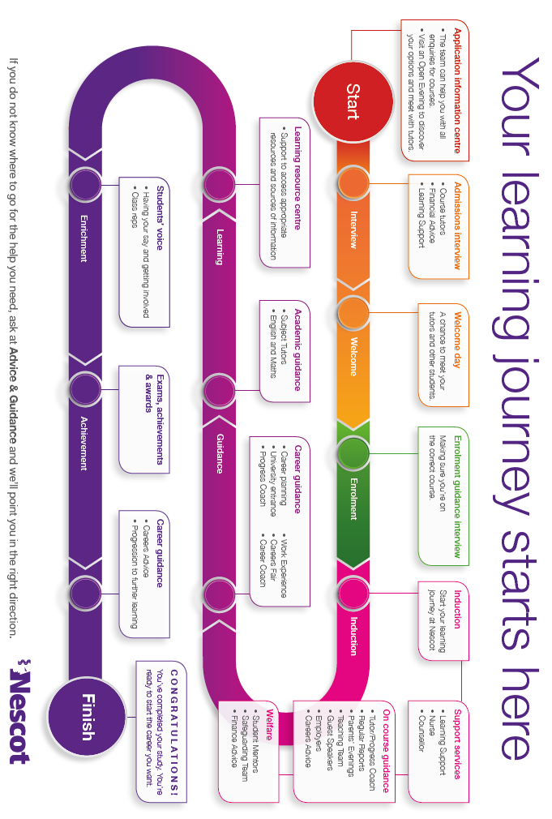

Appendix 2 – On Course Careers Education Programme

Students on our full-time further education study programmes are given the opportunity to engage in some or all of the careers related activities listed below during the course of their study at NESCOT.

Appendix 3 - Schools That We Work With

Listed below are the schools that we have recently worked with as part of our schools outreach programme.

 | Ashcombe School, Dorking |  |  | Beacon School, Banstead
 | Bensham Manor School, Thornton Heath |  |  | Blenheim School, Epsom
 | Carshalton Boy’s Sports College |  |  | Cheam High School
 | Chessington Community College |  |  | City of London Freemen’s School, Ashtead
 | Coombe Boy’s School, New Malden |  |  | Coombe Girl’s School, New Malden
 | Esher College |  |  | Esher High School
 | Glenthorne High School, Sutton |  | 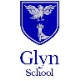 | Glyn School, Ewell
 | Greenshaw School, Sutton |  |  | Howard of Effingham School
 | John Fisher School, Purley |  |  | Meridian High School, New Addington
 | Oasis Academy, South Bank, London |  |  | Richard Challoner School, New Malden
 | Richmond upon Thames College |  |  | St Andrew’s RC School, Leatherhead
 | St Mary’s RC High School, Croydon |  |  | The Holy Cross School, New Malden
 | Woodcote High School, Coulsdon

Listed below are the schools that we have recently worked with as part of our school links programme.

 | Bedelsford School, Kingston |  |  | Blossom House School, Motspur Park
 | Cheam High School |  |  | Clifton Hill School, Caterham
 | Eagle House, Sutton |  | 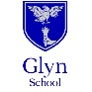 | Glyn School, Ewell
 | Sherwood Park School, Wallington |  |  | The Link Secondary School, Beddington
 | Westhill School, Leatherhead |  |  | Woodlands School, Leatherhead

Version | V3
Originator: | Head of Advice & Guidance
Approved By: | SMT
Date Approved: | 11th January 2018
Review Interval: | Annual
Last Review Date | 11th December 2017
Next review date | December 2018
Audience: | All Staff, External Stakeholders

