

**Equality & Diversity Statement and Objectives**

**2016 – 2020**

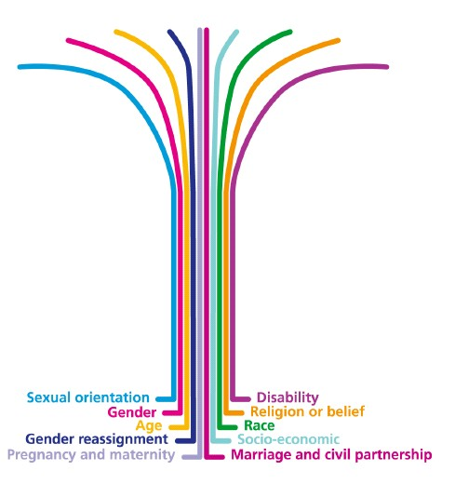

|  |  |
| --- | --- |
| Version: | 1 |
| Policy originator: | Deputy Principal |
| Date written: | March 2016 |
| Approved by: | E& D Working Group |
| Date approved: | March 2016 |
| Review interval: | 4 Years |
| Last review date: | n/a |
| Next review date: | Jan 2020 |
| Audience: | Staff, Students, Governors & Stakeholders |

1. Equality Policy Statement
   1. The purpose of this statement is to set out Nescot’s commitment to advancing equality and promoting diversity.

At Nescot, we are committed to advancing equality of opportunity, respecting and celebrating difference, eliminating discrimination, harassment and victimisation and fostering good relations between all who work, learn or use our services. We aim to continue to improve a working and learning environment in which all people have the opportunity to participate fully, give of their best and achieve their full potential in a climate free from discrimination or harassment. We recognise that all have a right to equality of opportunity irrespective of race, disability, gender, gender reassignment, age, nationality, sexual orientation, religion or belief, marital or civil partnership status, or socio-economic status, background or class.

* 1. The College will also ensure that through its equality and diversity policy it meets its public sector equality duty to:
     + Eliminate unlawful discrimination, harassment and victimisation and other conduct prohibited by the Act
     + Advance equality of opportunity between people who share a protected characteristic and those who do not
     + Foster good relations between people who share a protected characteristic and those who do not.
  2. Equality and diversity are central to all that we do, and fundamental to our mission and values:

**The College’s Mission is**:

“*To inspire our students to be the best that they can be*”

***The College’s Values are:***

* We put students’ success and wellbeing at the heart of everything we do;
* We have high expectations and aim for excellence;
* We are collaborative, striving to positively engage our students, staff and partners;
* We are committed to sharing good practice, entrepreneurship and innovation;
* We celebrate diversity and challenge bigotry;
* We are ethical and inclusive

Our new 4 year equality objectives are as follows:

***OBJECTIVE 1***

**Provide a welcoming and fully accessible environment for all protected characteristics**

**How will success be measured?**

* Increase each year the percentage of staff who more confident to be open about their identity
* Reduction in complaints about access to the building
* Student and staff ethnicity meets or exceeds local demographic profile
* Staff satisfaction rates with the working environment remain high and above 95%

***Objective 2***

**Ensure students perform and progress well and we take action to eliminate any gaps between groups**

**How will success be measured?**

* Satisfaction rates of students from protected characteristics remains high and above 89%
* Success rate gaps do not exceed 5% for protected characteristics

***Objective 3***

**Ensure gender pay gaps are addressed**

**How will success be measured?**

* Targeted reduction in gender pay gaps identified
* Ensure promotion/recruitment opportunities are made known to all staff

***Objective 4***

**Further develop the skills and confidence of staff, students & partners to promote and advance good relations amongst diverse groups**

**How will success be measured?**

* Satisfaction rates of students and staff from protected characteristics remains high above 90%
* Satisfaction with E & D training for both staff and students
* Staff and student satisfaction with the College’s work to promote a culture of good relations among diverse groups

***Objective 5***

**Consult and engage with under-represented staff and student groups to advance equality of opportunity and foster good relations**

**How will success be measured?**

* Develop a culture of open communication between staff and students and management and staff which is acknowledged in high satisfaction ratings
* Actively engage with under-represented groups and ensure they participate in staff and student forums

***Objective 6***

**Celebrate and publicise the positive outcomes of our diverse staff and students**

**How will success be measured?**

* Hold annual celebratory events for both staff and students
* All external publications will celebrate the achievements of our diverse workforce and student population