Animal Management

Recommended texts to help with your studies, these are not essential but if you would like to start reading up about your subject before September then these are recommended by the teaching team

Introduction to Animal Care

RSPCA Pet Care Guides
"Nick Baker’s British Wildlife: a month-by-month guide” by N Baker

“Small Animal Care and Management” by D Warren

Intermediate Level Studies

“Animal Biology and Care” [Paperback] by Sue Dallas and Emily Jewell
“The Complete Textbook of Animal Health & Welfare” by Jane Williams

More Advanced Studies

“Introduction to Veterinary Anatomy and Physiology Workbook” [Paperback] by Victoria Aspinall
“Introduction to Animal and Veterinary Anatomy and Physiology” [4th edition]
By Victoria Aspinall and Melanie Cappello

Suggested YouTube Videos

Basic and Intermediate Level

The Five Animal Needs
https://www.youtube.com/watch?v=VO7E1XIMTxM

Classification of Animals [Biology – Life Lessons] https://www.youtube.com/watch?v=ITrRMiQB8g4

Brian Cox – How has life on earth become so varied [Biology – wonders of life]
[https://www.youtube.com/watch?v=9JxdFxjR0jE
Circulatory and respiratory systems [Crash Course Biology] https://www.youtube.com/watch?v=9fxm85Fy4sQ

Rainforests – ecosystems and biomes [https://www.youtube.com/watch?v=UIbplCn8-zs

More Advanced Studies

How do fish make electricity [TedEd]?
https://www.youtube.com/watch?v=z0M7_HPSi14

Why are sloths so slow [TedEd]?
https://www.youtube.com/watch?v=-64U7WoBrqM&list=PLD018AC9B25A23E16&index=5

Immune System – Innate and adaptive immunity explained
https://www.youtube.com/watch?v=PzunOgYHeyg

Overview of cell structure
https://www.youtube.com/watch?v=URUJD5NEXC8

How the heart actually pumps blood [TedEd]
[https://www.youtube.com/watch?v=ruM4Xxhx32U

Animal Behaviour [Khan Academy]
https://www.khanacademy.org/science/biology/crash-course-bio-ecology/crash-course-biology-science/v/crash-course-biology-124

Frequently Asked Questions

Will I need specific ‘set books’ for my course?

No – for each topic, your tutors will provide you with your key learning materials and identify specific websites that you need to use for research. Additional materials will be available on Nescot’s Virtual Learning platform, which is called Weblearn, and the college Learning Resources Centre has a wide range of books, DVDs and animal journals that you can either borrow or scan relevant photos from when you need to.

What learning materials will I need?

You will need similar materials to those that you used at school or at your previous college. Tutors will expect you to have a folder for your coursework, pens and pencils, highlighter pens, a ruler, and a bag in which to put them all in.

What will I need for working on the Animal Care Unit?

All students are required, for health and safety reasons and professional standards, to wear steel capped boots and overalls when working on the Animal Care Unit. These are available for purchase from the college at enrolment, along with optional ‘Animal Studies’ polo shirts, sweatshirts, and fleeces. You will be expected to work outside in all sorts of weather, so you also need to make sure that you have warm clothes, a waterproof coat for rainy days, and sunblock when the sun comes out. Discretionary bursaries are available to cover the cost of purchasing your boots, overalls, and waterproofs, and further information regarding these will be sent out in your enrolment pack.
Do I need to bring a packed lunch to college?

The college has a number of food outlets, such as the main student refectory, a Starbucks, and the ‘Undercroft Café’. However, there are lots of places to sit and eat your own packed lunch, including large areas of grass and trees. It’s up to you what you bring for your packed lunch but remember that you will be expected to work hard in the classroom, and to carry out physical activities on the Animal Care Unit, looking after the animals. This means that you need a healthy lunch to keep you going through the day.

Task

You will be working with a diverse range of animals whilst you are with us in the Animal Studies department. For each of the following species, just a few of the animals that we have on the Animal Care Unit, research and note down at least three ‘fascinating facts’ about them:

A) Goat
B) Sheep
C) Chickens
D) Bearded Dragon
E) Corn Snake
F) Royal Python
G) Chinchilla
H) Ferret
I) Coati Mundi
J) Guinea Pig
K) Rabbits
L) Donkey
M) Axolotl
N) Degus

Task

1) Watch https://m.youtube.com/watch?v=jARH5kKAAQM

2) Choose a vegetable or fruit you have available and plant the seed (or if you have any seed packets for vegetables or fruit you could just use these instead).

3) Try and grow these seeds and complete a weekly diary of the changes the your seed goes through.as it grows into a plant.

Task

Plan and create an enrichment activity for a small animal. It should be made from cardboard and should be fun for the animal to play with. For example, at Christmas, our students made cardboard trees and hung cabbage leaves and sprouts from them for our rabbits. You could try hiding treats in toilet rolls with the ends folded over too.

DO ENSURE ALL METAL AND PLASTIC HAS BEEN REMOVED from the materials that you use.

Task

Create a presentation on an animal of your choice. This could be an animal which you have at home or an animal which you would really like to have but are unable to.

It can be a domestic species or an animal which lives in the wild. Your presentation should cover what the animal is, a little about the animal’s natural history, it’s appearance, what it eats, the sort of housing it should have, etc. Make sure that you include lots of labelled images. This task can be created using your choice of presentation software or can be neatly hand-written and contain drawings.
Task

Watch this short video from ‘Simon’s Cat’ and note down all of the common cat behaviours that you recognise.

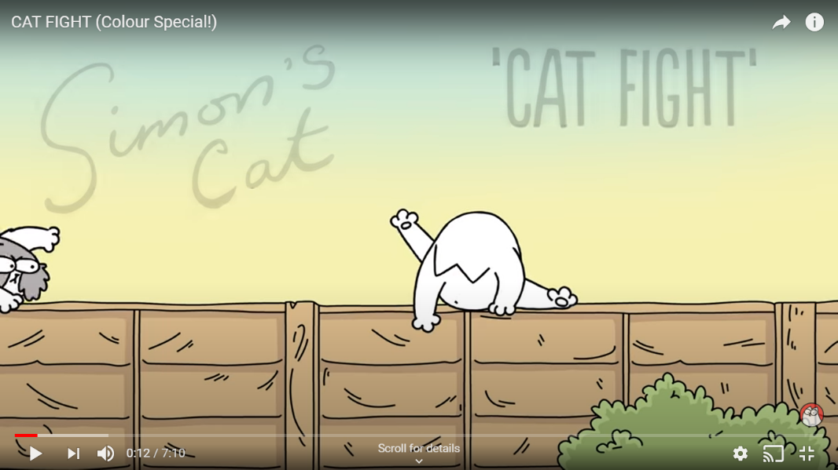

Task

Spend some time quietly observing an animal that you have at home. If you aren’t sharing your lockdown with any pets then you will need to carry out your observation on a ‘human animal’ instead! Learning how to observe and record animal behaviours is an important animal care skill to develop.

- Spend 10 minutes watching your ‘animal’. What are the key behaviours that you saw? For example, chewing, washing, sleeping, twitching, etc

- Fill in the left-hand column of each of the charts provided on the next page to show the key behaviours that you noticed.

- Now chose 4 separate periods of time, each lasting 5 minutes, over the period of a week, to formally observe and record the behaviours that you see. Try to choose a different time of day [or night] for each of your observations. You will need to put a cross in the relevant box to show what your animal was doing in each minute. If they show a new behaviour that you didn’t see when you first did your informal observation…don’t worry…just add it to one of the spare lines on your chart.

- Finally, create a graph or pie-chart to show how much time your animal spent doing each of the behaviours you identified.

Animal Behaviour Recording Chart

Behaviour | Min 1 | Min 2 | Min 3 | Min 4 | Min 5

Behaviour | Min 1 | Min 2 | Min 3 | Min 4 | Min 5

Behaviour | Min 1 | Min 2 | Min 3 | Min 4 | Min 5

Behaviour | Min 1 | Min 2 | Min 3 | Min 4 | Min 5

Task

Being able to assess your animal’s basic health data is an essential part of ensuring that your animal remains healthy. It is useful to practice measuring the respiratory rate [how fast the animal breathes], and the pulse rate [the sensation of blood passing through a major artery which gives information on the function of the circulatory system].
This task needs a pet [or a human if you do not have an animal at home that you can use], a timer, and a pen to record the results on the chart below.

Species of animal used:

Pulse rate per minute

Respiratory rate per minute

To measure the respiratory rate: Watch your animal’s chest rising and falling. Count every time the chest rises over a period of 30 seconds and then double the figure to give you the result for a minute.

To measure the pulse rate: Locate the femoral artery on the inside of the animal’s thigh [see diagram below]. Lightly touch the artery and count the number of ‘pulses’ of blood that you feel passing under your finger over a period of 30 seconds. Double the figure to give you the result for a minute. Don’t worry if you struggle to find the pulse…..this can be quite difficult and can sometimes require a little bit of practice.

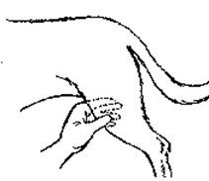

Task

You will usually find a set of ‘Lab Rules’ in a science lab. They are there for your safety. The drawing below shows a lab where there are no safety rules.

1 Make a list of all the things going wrong in this lab.
2 For at least three of your answers, write a safety rule.
3 Design a poster for your lab, showing three safety rules and the reason for having them.

