BRICKWORK COMMON TOOLS AND MATERIALS

Below are pictures of common tool and materials used by bricklayers – use the following websites to names that and find out how much they are to purchase:

https://www.toolstation.com
https://www.screwfix.com
https://www.diy.com
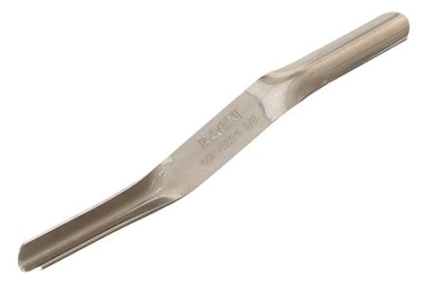 | This tool is used to finish off the brick joints - What is it called and how much is one to purchase?
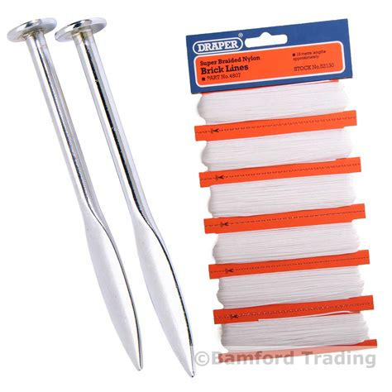 | This tool is used to help bricklayers keep the bricks level and in alignment - What is it called and how much is one to purchase?
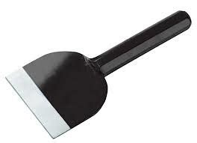 | This tool is used for cutting bricks in half or to a set size - What is it called and how much is one to purchase?

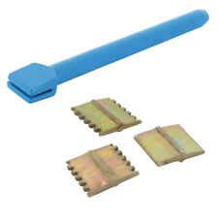 | This is a bricklayers chisel - What type of chisel is it and how much is one to purchase?
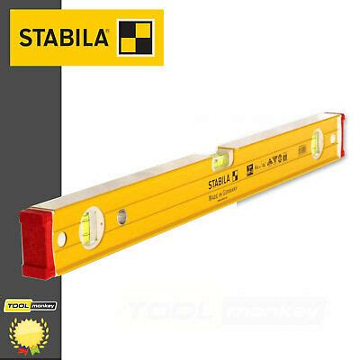 | Do you know the name of this tools and what is it used for?  See if you can find the cost this tool but it needs to be either 1000mm or 1200mm long ?
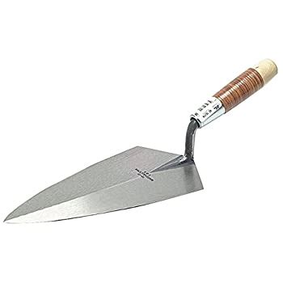 | This is a top of the range brick tool made by Marshalltown  What is the name of the trowel, what country does it come from and how much is one to purchase?

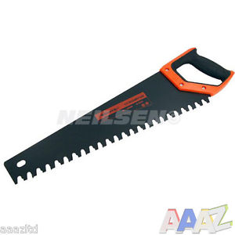 | This is a masonry saw what material would you be able to cut with this saw  What is it called and how much is one to purchase?

Can you name 3 types of brick or block commonly used by bricklayers?

What is the tool cost of the tools only?
(show how you added up the cost of the tools below)

How much would the total cost of the tools be if you got 5% discount?
(show your calculations below)

