CARPENTRY COMMON TOOLS AND MATERIALS

Below are pictures of common tool and materials used by carpenters – use the following websites to names that and find out how much they are to purchase:

https://www.toolstation.com
https://www.screwfix.com
https://www.diy.com
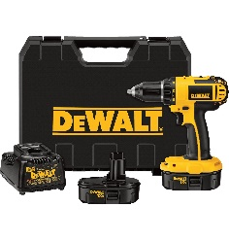 | What type of power tool is this and how much is one to purchase?
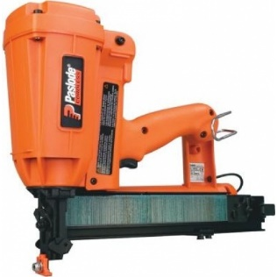 | This is a specialist power tool – Can you name it and how much is one to purchase?
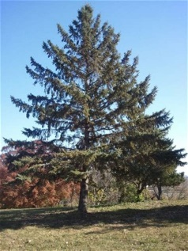 | This is a needle type of tree what kind of timber will it produce?

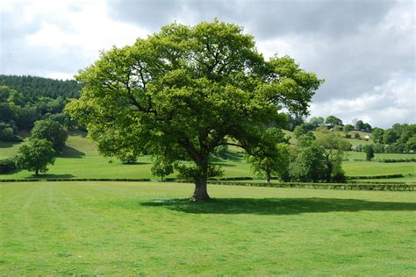 | This is a broadleaf type of tree what kind of timber will it produce?
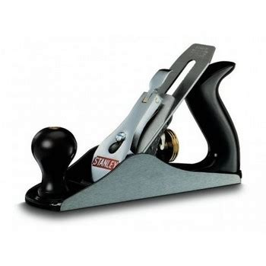 | This tool is used to make rough timber smooth or to remove excess material - What is the name of the tool and how much is one to purchase?
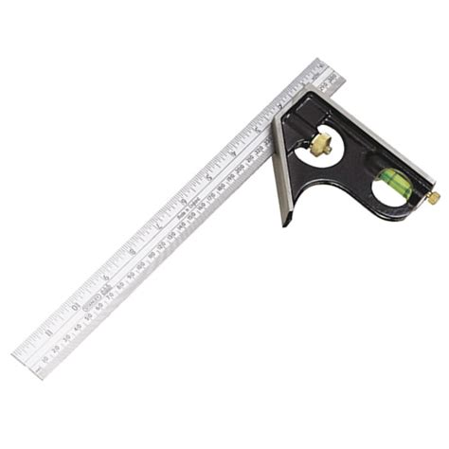 | This tool is use to mark timber to help ensure cuts are straight and true - What is the name of the tool and how much is one to purchase?

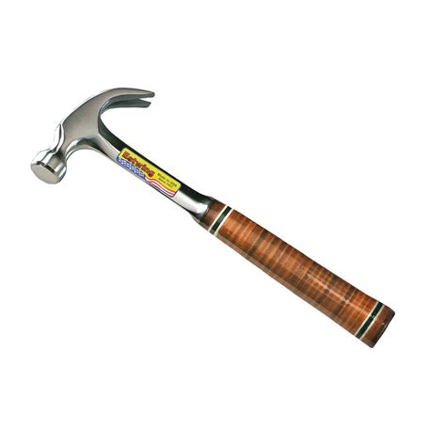 | This is a top of the range hammer made by Estwing -  What is the name of the hammer, what country does it come from and and how much is one to purchase?

Name 3 types of HARD wood

Name 3 types of SOFT wood
I.
II.
III.
What is the tool cost of the tools only?
(show how you added up the cost of the tools below)

How much would the total cost of the tools be if you got 5% discount?
(show your calculations below)

