Hospitality and Catering Industry

- Hospitality is the 3rd largest private sector employer in the UK, double the size of financial services and bigger than automotive, pharmaceuticals and aerospace combined.
- The hospitality sector generates £38 billion in taxes, for the government, which funds vital public services in the UK (hospitals, roads, police etc.).
- Hospitality represents 10% of UK employment, 6% of business and 5% GDP.
- The hospitality sector employs 3.2 million people in the UK.
- Businesses which make up the hospitality sector include:
- Hotels, restaurants, coffee shops, pubs and bars, leisure parks, stadia, nightclubs, contact caterers, food service operators, entertainment and visitor attractions.
- Worldwide the hospitality industry is worth approximately $10 trillion (£8.029 trillion).

Did you know?

- The world’s oldest existing restaurant opened in China in 1153
- An onion, apple and potato all have the same taste. The differences in flavour are caused by their smell.
- We eat more baked beans in the UK, than the rest of the world combined.
- Chilies have been eaten since at least 7000BC in South America, and at one point were used as currency.
- Salt is one of the few spices that is all taste and no smell (take a smell).
- It takes 10kg of milk to make 1kg of cheese.

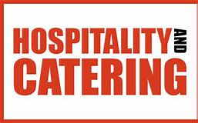

Task

Research the key temperatures in the catering industry which caterers need to know. Mark them on the thermometer below:

- Safe freezer temperature
- Freezing point of water
- Usual safe fridge temperature
- Body temperature of humans
- Boiling point of water

Task

Research the different colours of chopping boards that are used in the catering industry and what they are used for.

Why is it so important to use the correct colour of chopping board?

Task

Research the answers to the following questions:

- What is meant by the “Core temperature of food”?

- Why is it important to check and know the core temperature of foods?

- How can a caterer assess the core temperature of food?

Task

Knife Skills: cutting techniques

It’s important that you use the correct cutting techniques with your knives. Get ahead of the course and practise some knife skills at home.

- Watch the video below with Russell Brown on how to cut a carrot paysanne.
https://www.youtube.com/watch?v=2LmCGBFaDlw

- Now give it a go at home and try chopping the following

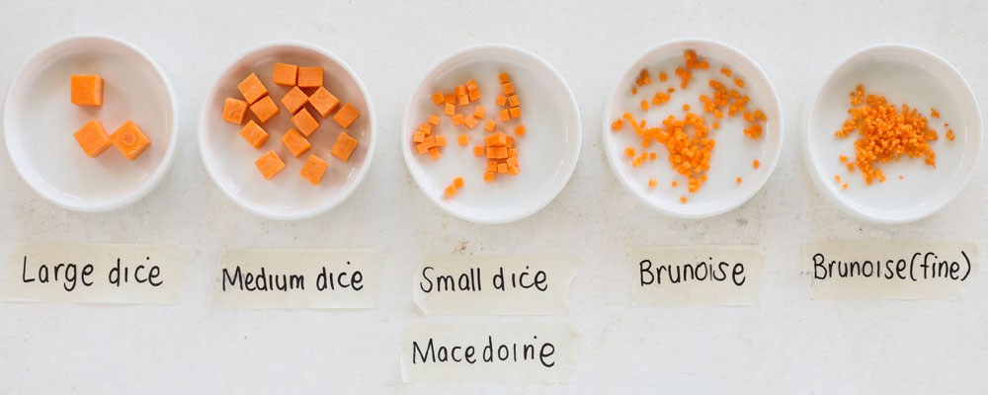

- Now click on the link and watch chopping an onion with Jamie Oliver’s mate Pete
https://www.youtube.com/watch?v=fs8cQ_tjsF8

- See if you can chop an onion like that….
Project Task

A restaurant owner has decided to offer healthier choices on the menu, and has asked for ideas from staff members

You are required to choose a dish that might normally be found on a traditional lunch menu (e.g. fish and chips, lasagne) and suggest how this dish could be changed to be healthier and appeal to the same market.

You should include information on the following

- How the suggested dish is healthier and meets nutritional guidelines
- The benefits of using healthier ingredients to the restaurant and customers
- The consequences of not using healthier ingredients to the restaurant and customers
Step | Task | Tick when completed
1 | Traditional dish vs healthier dish  - List ingredients and method for a traditional dish (recipe) List the substituted healthier ingredients and method  Think about adding extra vegetables, reduce added fat and sugar also think about healthier cooking methods  For example:  Traditional dish Healthier dish  Deep fried haddock in beer batter with triple cooked chips Steamed fish with salad and sweet potatoes  - Describe the changes that can be made to dishes to make them healthier choices according to current nutritional guidelines  - Describe why it is important for catering establishments to offer healthier choices
Step | Task | Tick when completed
2 | Nutritional guidelines  Match/outline current nutritional guidelines  For example, daily allowance of salt is 6g web link below will help.  https://assets.publishing.service.gov.uk/government/uploads/system/uploads/attachment_data/file/618167/government_dietary_recommendations.pdf  Watch the video  https://www.nutrition.org.uk/healthyliving/healthydiet/eatwellvideo.html  Now make some basic additional suggestions that meet the nutritional guidelines
3 | Physical benefits of healthier ingredients  e.g improved health, reduced risk of some illnesses, describe illnesses  Benefits of healthier dishes to the restaurant
4 | Consequences of not having healthier ingredients  e.g. obesity, low immune system  Consequences of not having healthier ingredients to the restaurant
5 | Research one source of information on nutritional guidelines and add in the website, book or journal to your assignment.

Frequently Asked Questions

- When will I get my timetable?
- On your first day at College

- How long is a College day?
- A full day at College is 9.00 - 4.45 however this will depend on your individual study programme. Some students will have a full timetable due to either GCSE or Functional Skills maths and English retakes.

- What do I wear to College?
- Comfortable casual clothing

- When will my uniform and knives arrive?
- This will usually arrive 3-4 weeks after it has been ordered

- What sort of things do we cook?
- Soups, bread rolls, biscuits, sponge puddings, tarts, pancakes pasta dishes, roast chicken, braised meat dishes, vegetable dishes and regenerated dishes

- When will we start cooking in the training kitchens?
- After you have achieved your Unit 202 Food Safety about 3 weeks into your course.

- Will everyone else have more experience at cooking than me?
- Some students may have done catering or Food technology at school and have some experience but you will all be staring at the same level.

