Construction
Access equipment used in the construction industry
Working at Heights

(1). Working at Height Regulations 2005 cover a wide range of access equipment please name the items below and give an example of where they might be used?
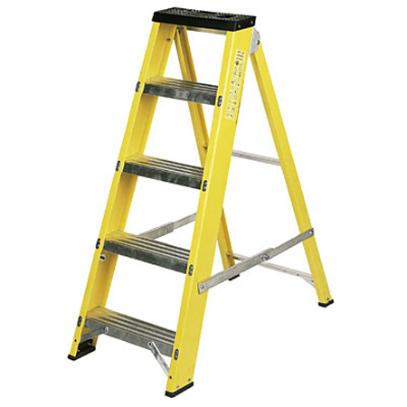

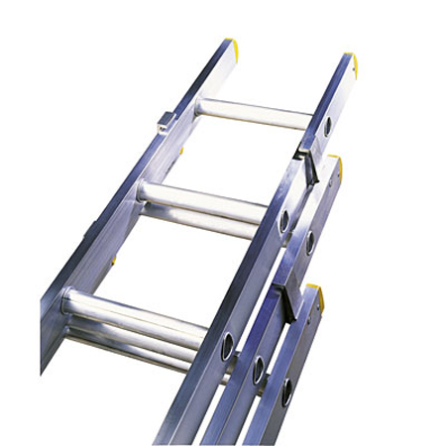

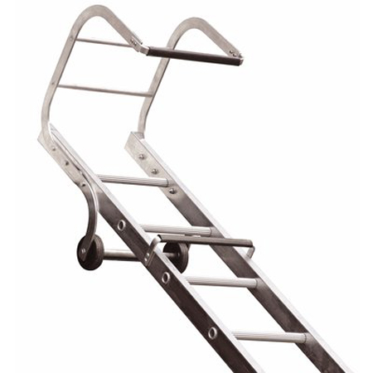

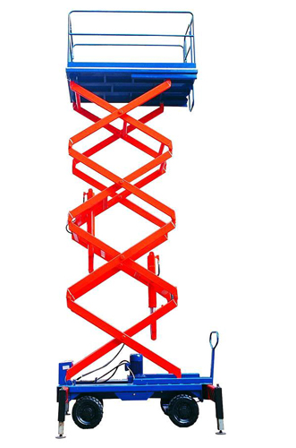

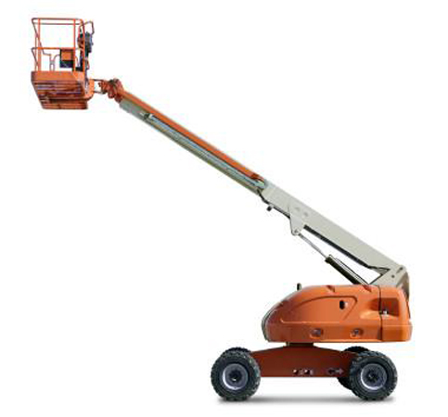

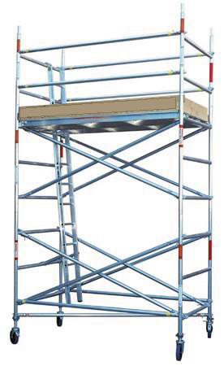

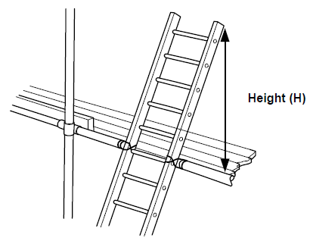
- What is the approximate height that a ladder should project above a working platform for access purposes?
- 100mm
- 200mm
- 600mm
- 1000mm

- What is the required distance from the bottom of a wall to the base of a ladder,
if the vertical height from the base of the wall to the top of the ladder is 6m?
- 500mm
- 1,000mm
- 1,500mm
- 2,000mm

- Please research the 3 classes of ladders and their safe working load and list below. Also list what materials ladders can be made from?

i). Ladder Class: ……………………………………………………
Safe working Load: ……………………………………………...
What is material is it made of? ………………………………………………………..

ii). Ladder Class: …………………………………………………….
Safe working Load: ……………………………………………….
What is material is it made of? ………………………………………………………..

iii). Ladder Class: ……………………………………………………
Safe working Load: ……………………………………………….
What is material is it made of? ………………………………………………………..
PLEASE WATCH THE FOLLOWING SHORT FILM:

Working from Height - Site Safety Plus Short Film
https://youtu.be/WKebfmZz2O0

Other useful reference materials:

Ladder Safety Video:
https://youtu.be/S1cfcQFv2lE

Classification of ladders:
https://www.ladders-direct.com/content/6-british-and-european-ladder-certification-standards

HSE Safe use of ladders and step ladders:
https://www.hse.gov.uk/pubns/indg455.pdf

