Construction site safety

Working in the construction industry can be hazardous as the nature of the work is so varied and around 2 million people working in the construction industry. Sadly accidents at work do occur and the injuries are often serious or even fatal. Over the last 5 years on average there are 36 deaths to workers and 5 deaths to members of the public because of accidents on UK construction sites. In 2018/19 there were 54,000 reported non-fatal injuries to construction workers, obviously there are many injuries and accidents that go unreported.

Construction includes three broad industry groups

- Construction of buildings – general construction of buildings, including new work, repair, additions and alterations
- Civil engineering – civil engineering work, including road and railway construction, and utility projects
- Specialised construction activities – covering trades that usually specialise in one aspect, common to different structures. For example: demolition, electrical, plumbing, joinery, plastering, painting and glazing.

What is the HASAWA 1974?
Why is it important to report all accidents including near misses?
- The rights and responsibilities as the employee and that of the employer
- Safety and protective equipment
- Common construction accidents

The Health and Safety at Work Act 1974 is the main piece of legislation covering occupational health and safety in Great Britain. It is sometimes referred to as HASAWA 1974
It sets out the general duties which:
- employers have towards employees and members of the public
- employees have to themselves and to each other
- self-employed people have towards themselves and others

Reporting of accidents and near misses

When most people think of workplace safety, they think of accidents, injuries, and fatalities. But reporting near misses that happen on the job can be just as important as recording accidents.

A near miss is a potential health or safety issues that did not cause accident, death, or injury, but logically might have done so and in most cases, it is only sheer luck that prevented it being more serious. It is important therefore that it is reported to prevent it from occurring to others who may not be as ‘lucky’ as you! It is your duty to ensure your own safety AND that of others.

Rights and Responsibility of the Employee (you) and the Employer

Your rights as an employee
Your rights as an employee is to be able to work in a safe and healthy environment, the most important of these rights are:
- to have any risks to your health and safety properly controlled
- to be provided with any personal protective and safety equipment free of charge by your employer
- to stop work and leave your work area, without being disciplined if you have reasonable concerns about your safety
Your responsibilities
Your most important responsibilities as an employee are:
- to take reasonable care of your own health and safety and that of other workers
- to take reasonable care not to put other people - fellow employees and members of the public - at risk by what you do or don't do in the course of your work
- to co-operate with your employer, making sure you get proper training and you understand and follow the company's health and safety policies
- not to interfere with or misuse anything that's been provided for your health, safety or welfare
- to report any injuries, strains or illnesses you suffer as a result of doing your job including near misses
- not to undertake any work if you are under the influence of drugs or alcohol, many sites now have introduced random alcohol and drugs testing.
Employer Responsibilities:
Your employer has a 'duty of care' to make sure, as far as possible, your health, safety and welfare while you're at work. Below are only a few examples of what you can expect your employer to undertake to ensure your safety whilst at work:
- make the workplace safe by undertaking risk assessments to spot possible health and safety hazards.
- provide protective clothing or equipment free of charge
- tell you about any potential hazards from the work you do - chemicals and other substances used in your job - and give you information, instructions, training and supervision as needed
- ensure that plant, machinery tools and power tools are safe to use
- prevent or control exposure to substances that may damage your health
Safety & Protective Equipment
Whilst working in construction your employer has a duty to keep you safe and to provide you with Personal Protective Equipment. This may vary from site to site but would generally consist of high visibility clothing, steel toe capped boots and hard hats, safety goggle and gloves. Other with be provided dependent on the nature of your work, this may include ear defenders, dust masks and knee pads are also common items of PPE.

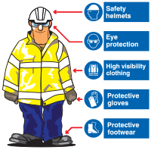

Common Construction Accident

Tripping Hazards
- The most common hazard is that of trips and slips, such as tripping over cables or holes in the ground that have been created as part of the construction/building process. Slips often occur due to wet floors, fluid spillage such as oil or slipping on muddy surfaces.

Falls from Height
- One of the most serious work accident is when a worker falls from a ladder or scaffolding which can cause injuries such as broken bones, fractures, back injuries and head injuries. Most construct site deaths involve falls form height.

Falling Objects
- You may be working on a construction site when an object is dropped onto you from above without any warning or the ability on your part to move out of the way. A falling object can cause an injury which makes it impossible for you to continue working. Injuries can vary from minor cuts and bruises to serious crush injuries and head or brain injuries.

Defective Equipment
- If your employer provides you with power tools to allow you to complete your job then they are responsible for keeping that work equipment in a good working order and for carrying out repairs to the equipment should it become defective. However it is your duty to inspect equipment prior to use, use it in the correct manner and DO NOT adapt it in any way, for instance remove the safety guard. It you notice equipment is faulty DO NOT USE and inform you employer por supervisor.

Construction Vehicle Accidents
- Whilst working in the construction industry provision must be made for vehicles and pedestrians so that they can circulate in a safe manner. If a pedestrian is hit by a site vehicle then injury or a fatality will occur. It is important that construction sites have clearly designated pedestrian walkways and you stay within these boundaries.

Excessive Noise and/or Vibrating Tool Hazards
Noise and vibrating tools are also a cause for concern whilst working in the construction industry as excessive noise from power tools can cause hearing loss or problems such as tinnitus (ringing in the ears).
The vibration from power tools can cause nerve and tendon damage to the hands, arms and wrists which if experienced can be extremely debilitating with reduction and sometimes total loss of grip strength this is commonly known as ‘vibration white finger'

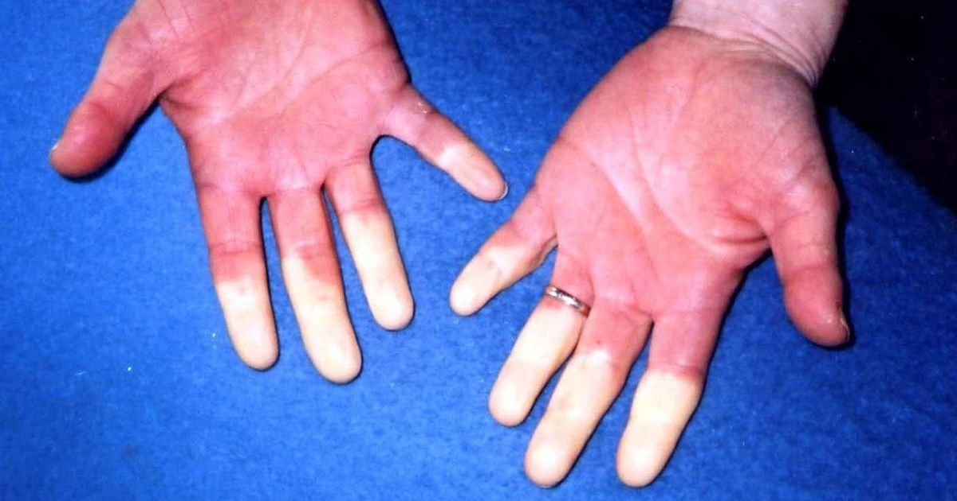

Other substances hazardous to health
- Contact with chemicals or irritants such as carbon monoxide or asbestos dust can have devastating consequences on your health and life. Substances may be transmitted inhaling (breathing in), ingesting (swallowing) or direct contact with the skin or eyes. All materials that are hazardous to health are governed by the Control of Substances Hazardous to Health Regulations 2002 (known as COSHH)

Please watch the following video:

https://youtu.be/VSVfRbcMJps

Other useful resources to support your learning:

Mind you step HSE video
https://www.hse.gov.uk/construction/campaigns/watchyourstep/video/index.htm

What you must know before working on a construction site video
https://youtu.be/jHas7eEsBdc

Construction site safety training video
https://youtu.be/ZjSxDRYoO_4

Now assess your learning:

1). What does the abbreviation HASAWA stand for?

2). Who has roles and responsibilities under HASAWA 1974? (Circle one answer)

a). Employers
b). Employee’s
c). Self-employed people
d). All the above

3). Is it necessary to report ‘near-miss’ accidents – Yes or No (Circle one)
Why do you think this?

4). Is you had concerns over your safety of that of others you should (Circle one)
a). Ignore it as nothing has happened yet
b). Wait until you go home and tell a friend or parent
c). Stop work immediately and tell your employer of supervisor
d). Carry on working until you next see your supervisor and tell them you concern then

5). What does the abbreviation PPE stand for?

6). List the most common 5 pieces of PPE used by construction workers

7). On average how many deaths occur on UK construction sites? (Circle one)
a). 12
b). 41
c). 30
d). None

8). How many reported non-fatal accidents occurred in 2018/19 on UK construction sites? (Circle one)
a). 14,000
b). 54,000
c). 35,000
d). 5400

9). What is the most common hazard or accident that occurs to construction workers?

10). Most deaths on UK construction site involve what type of hazard?

11). What piece of PPE equipment would you recommend to protect you from falling objects?

11). What piece of PPE equipment would you recommend for protection from excessive noise?

12). If you were to operate a hammer drill or another vibrating tool for very long periods of time, what injury may you develop?

13). What does the abbreviation COSHH stand for?

14). Industrial glues and adhesives are hazardous to health. What 3 pieces of PPE would you recommend wearing?

a).

b).

c).

