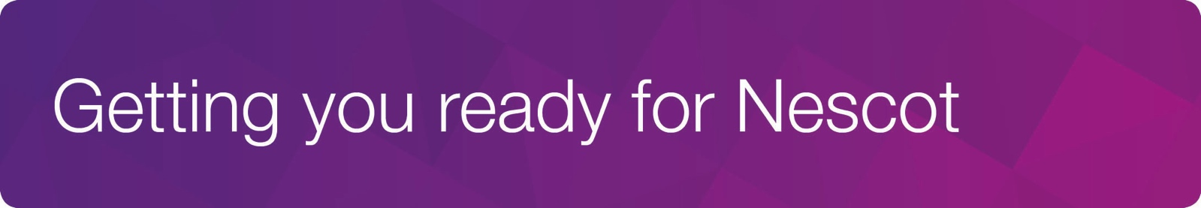

UAL Creative Media Production: Level 2 and 3

About Us

- We're really looking forward to you joining us in September. Our course is designed to reflect the film and television industry whereby you will develop your creative thinking side as well as learn the technical aspects necessary for creating a film. You will learn how to film and edit using our industry standard equipment and editing software. Additionally you will have the opportunity to go on international trips and work closely with people who've worked in the industry themselves. You will complete a diverse range of projects throughout your time here such as, music video, documentary, short film and you will even get the chance to work on your own final major project at the end of the academic year. All this will put you in good stead for either full - time employment or higher education.
Activity ‘Day in the life of Lockdown’

- We would like you to create a 60 second film on a "Day in the Life of Lockdown " whereby you document what the experience means to you. You could choose to focus on your own day or you may choose to document a member of your household or both! Whether that be, completing school work, walking the dog, baking, or being together as a family. It doesn’t matter how you choose to interpret the brief as long as it is creative, honest and safe!

Filming and Editing

- You can shoot your film simply on your phone but we encourage you to film in landscape. In terms of editing there are a few editing apps that you can use such as; Splice, Imovie & Quik. We're really excited to see what you come up with, and remember be as creative as possible!

Extension

- If you cannot shoot the film for any reason or wish to do an extension activity, why not produce a script and a storyboard for your film.

Submissions

- Please send your submissions to our instagram account @nescotcreative and we will add them all to our stories!

