Games, Animation and VFX (Next Gen)

Activity: Personal Avatar

- We would like to set you an activity that will help you get to grips with the key aspects of the Games, Animation and VFX course and industry. This task will also form part of your induction in September.

Create an Avatar

Software

- Create an avatar of yourself using MagicaVoxel to bring to show us on your first day at Nescot.
- Watch the following short tutorials until you are ready to have a go yourself!
https://www.youtube.com/playlist?list=PL3CE19eBHSkE1G6xLAtlPMT-adTZ01rHD

Extension

- Loving the software? Don’t stop at an avatar. Make other interesting people or objects to bring and show.

Submission

- Once you’re done send us a picture of your avatar to our instagram @nescotcreative and we will add them to our stories.

- If you are unable to create your avatar via MagicaVoxel why not draw a series of sketches as to what your avatar would look like and you can create it when you join us in September!
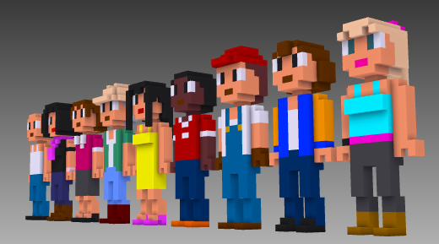
We look forward to seeing you in September!

